DriverPass Client Presentation - Slides and Speaker Notes
Thomas Fronteddu | CS-255 | Project Two

Slide 1: DriverPass System Analysis
Thomas Fronteddu
Notes:
No speaker notes required for this slide.

Slide 2: System Requirements
- Customers can create an account and book, cancel, or change a driving lesson online at any time (functional)
- The system automatically receives updates from the DMV so practice tests always reflect the latest rules (functional)
- The system is available online at all times, so customers and staff can rely on it whenever they need it (nonfunctional)
- Customer information and payment details are protected, with different access levels for different staff roles (nonfunctional)
Notes:
For DriverPass, I focused on two things the system absolutely needs to do, and two qualities it needs to have. On the “must do” side: customers need to be able to create an account and book, change, or cancel a driving lesson online whenever it’s convenient for them, and the system needs to automatically pull in updates from the DMV so your practice tests always match the current rules and questions. On the “how well it works” side: the system needs to be available and reliable any time someone wants to use it, and it needs to keep customer information and payment details protected, giving different staff members only the access they actually need for their job. Together, these requirements make sure the system does what your customers and staff need it to do, while also being safe and dependable to use.

Slide 3: Use Case Diagram
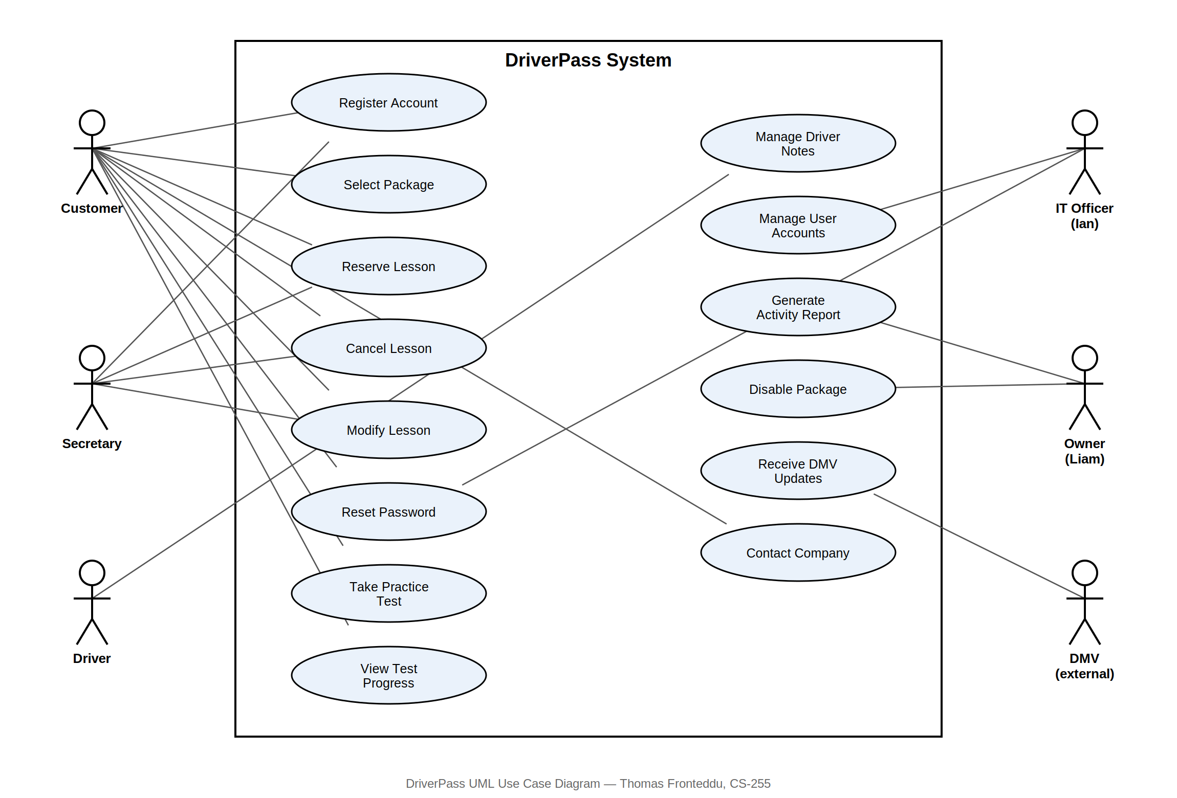
Notes:
This diagram shows everyone who interacts with the DriverPass system, and what each of them can do with it. Your customers can create accounts, book and manage their lessons, take practice tests, and track their progress. Your secretary can also book and manage lessons on a customer’s behalf. Ian, your IT staff member, can manage accounts and reset passwords. You, as the owner, can pull activity reports and turn packages on or off. And the DMV connects into the system automatically to keep your practice materials current. I built this out to make sure every piece of functionality you described in our meeting — lesson scheduling, practice tests, account management, reporting — has a clear home in the system.

Slide 4: Activity Diagram
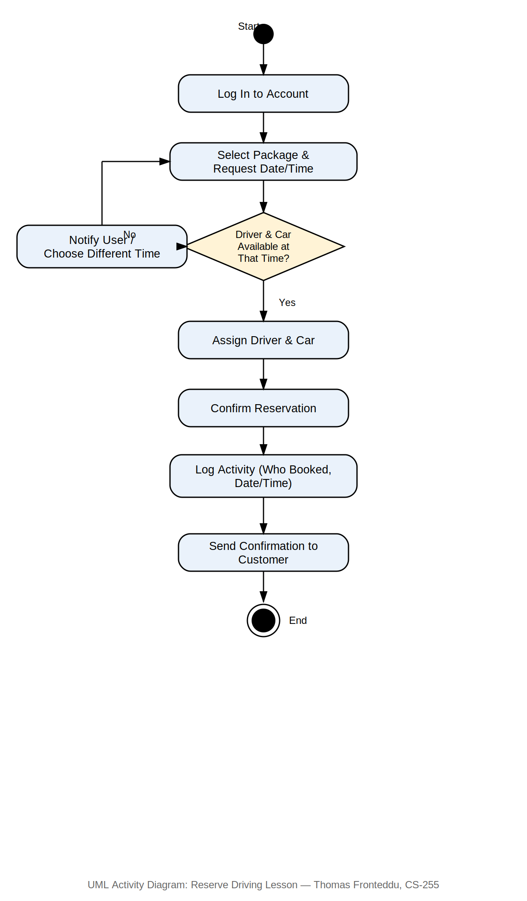
Notes:
This diagram walks through what happens, step by step, when a customer books a driving lesson. They log into their account, choose a package, and pick a date and time. The system checks whether a driver and car are actually free at that time. If so, it assigns them and confirms the booking, and it keeps a record of who made the booking and when, which covers the tracking you mentioned wanting for accountability. If a driver and car aren’t available, the customer is notified right away and asked to pick a different time, so there’s no confusion about a booking that can’t actually happen.

Slide 5: Security
- Every person who uses the system has their own login, and only sees the information and options relevant to their role
- Payment and personal details are stored securely, and are never visible to staff who don’t need them to do their job
- If a customer forgets their password, they can reset it themselves without needing to call in
- Every reservation, cancellation, and change is automatically recorded, so it’s always clear who did what and when
- The system is hosted in the cloud, so backups and security updates are handled automatically without extra work from your team
Notes:
Security was a big focus throughout this design. Every user — whether it’s a customer, your secretary, or Ian — only sees and can do what’s appropriate for their role, so nobody has more access than they need. Payment and personal information is handled carefully and kept away from staff who don’t need to see it. Customers can reset their own password if they forget it, so they’re never locked out waiting on someone else. And because every booking, change, and cancellation is automatically logged, you’ll always be able to see who did what, which protects both you and your customers if something ever needs to be looked into. On top of that, since everything runs in the cloud, security updates and backups happen automatically in the background.

Slide 6: System Limitations
- Adding or removing an entire package (not just turning one off) will require a developer’s help rather than something staff can do on their own
- Information can only be changed while connected to the internet, to avoid conflicting or duplicate records
- The system depends on receiving timely updates from the DMV; if the DMV is delayed in sending an update, practice tests may briefly lag behind the latest rules
- Since the system runs in the cloud, it requires a working internet connection for most day-to-day functions
Notes:
No system is completely without limitations, so I want to be upfront about a few. Right now, adding or removing an entire package — not just turning one off — will need a developer’s help rather than something your team can do directly, since that kind of change touches the core of the system. Data can only be updated while someone is connected to the internet, which prevents conflicting records but does mean offline changes aren’t possible. The system also depends on the DMV sending updates in a timely way; if they’re slow to send something, your practice tests could briefly lag behind. And since the whole system lives in the cloud, a reliable internet connection is needed for most day-to-day tasks.

